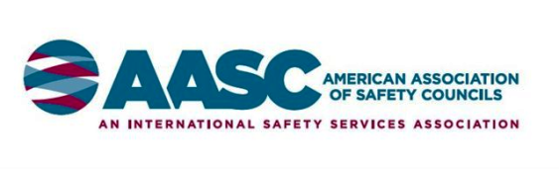

www.safetycouncils.org

AMERICAN ASSOCIATION OF

SAFETY COUNCILS

SCHOLARSHIP PROGRAM

American Association of Safety Councils Scholarship

$1,000 per year Maximum

The "American Association of Safety Councils Scholarship" is a maximum scholarship of $1,000 per year.

Eligibility:

- Any employee or his/her family member (to include legal guardianship) of an AASC Safety Council. Employment at an AASC Safety Council shall be for a period of not less than twelve months.

- AASC Safety Council member company employee or family member. Membership must be current and established for not less than twelve months.

- Any board member of an AASC Safety Council or his/her family member.

The scholarship applicant must currently be a full-time student in the sophomore level or higher at an accredited college or university. The person must have a cumulative GPA of 2.75 or higher and will be selected by the Scholarship Committee based on involvement in community/school organizations, leadership positions held, awards received and a strong emphasis will be placed on a submitted essay relating to how safety and health are important in their life and/or career.

Application deadline is March 1, 2018 to be considered for the 2018
American Association of Safety Councils Scholarship.

2018 Scholarship Application

Section One - General Information Regarding Applicant

Name
First M.I Last
Address (Permanent Residence)

Street

City State Zip

Phone Email

Section Two - Name of Safety Council Sponsor

(Sponsor Council is REQUIRED or application will be disqualified. Do NOT leave blank. Press F1 for help.)

Choose from the following list:

Are you an employee of this safety council? Yes No

If no, is a family member an employee or board member of this safety council? Yes No

If yes, what is their name? Relationship

If no, you or a family member must be employed by an organization that is a current member of your sponsoring safety council.

What is the name and address of that organization?

Name

Street

City State Zip

Are you an employee of this organization? Yes No

If no, name of family member employed by this organization

Relationship

Section Three – College/University

Name of College/University attending

Street

City State Zip

Phone Number

What is your current grade level? Press F1 for help

List school and/or community organizations in which you have been actively involved:
Name of Group and (Start/End) Dates of Participation

List positions of leadership and start/end dates you have held in school or community organizations:

List awards and commendations you have received, reason why and date received

Section Three – College/University “cont.”

List your intended career path and specific degree or certification you are seeking.

Section Four - Essay

On a separate sheet, please type 500 words or less why health and safety are important in your life and in your chosen career.

Section Five – Final Instructions

You must include with your application, a copy of your most recent college/university transcript or a copy of your most recent list of courses with the respective grades and overall grade average.

The award recipient will have $1,000 submitted directly to their college or university. Please indicate to whose attention the funds should be sent at the school.

Attention:
Student ID #:

Application deadline is March 1, 2018. Completed applications should be emailed to Brandy Howard, Scholarship Committee at bhoward@safety.org.

Only the scholarship award winner will be notified. The recipient will be notified by June 1, 2018.

You must sign and date your application to attest that the information provided in your application is accurate and all questions have been answered truthfully. (Electronic signatures are acceptable)

Failure to submit completed application and required documents will result in an immediate disqualification.

Printed Name Date

Signature

